OPM – SCRD – New System Deployment Guide

Revision History
Author | Revision Number | Date | Comments
lukashov | 1.0 | 01/29/2014
lukashov | 1.1 | 01/30/2014
lukashov | 1.2 | 02/21/2014 | Added instructions for OPM Web Application with Business Rules Engine integration assembly. Removed instructions for OPM Frontend Account And Payment Integration Assembly and BRE Interest and Deduction Calculation module assembly.
lukashov | 1.3 | 03/08/2014 | Added deployment instructions for Windows Integrated Security in an AD domain.

1. Organization of Submission 3
2. Application Setup 3
3. Environment Configuration 3
1.1 RHEL VM 3
1.2 Microsoft SQL Server VM 7
4. Deployment Instructions 12
1.3 OPM Web Application with Business Rules Engine integration assembly 12
1.4 OPM Data Migration module assembly 14
1.5 Test Data 15
5. Starting 15
1.6 OPM Web Application with Business Rules Engine integration assembly 15
1.7 OPM Data Migration module assembly 15
6. Verification 15
7. Resource Contact List 16

Organization of Submission
The submission contains this deployment document only. The code for deployment is hosted in SVN https://coder.topcoder.com/tcs/clients/coeci-opm/Delivery/Code/.

Application Setup

System and 3rd party software
The SCRD application is deployed with the following stack
- RHEL 6.4
- Java 6 (http://www.oracle.com/technetwork/java/javase/downloads/index.html)
- JBoss EAP 6.1 (http://www.jboss.org/jbossas/downloads/)
- Ant 1.8.1 (http://ant.apache.org/)
- PostgreSQL 9.2.4 (http://www.postgresql.org/)

The legacy SCRD database and the AD domain for Windows Integrated Security is deployed with the following software
- Windows Server 2012 Standard 64bit
- Microsoft SQL Server 2012

The following 3rd party libraries are deployed and the packaged with the submission
- Drools 5.5
- jBPM 5.4
- Jackson 2.3.1
- Spring MVC 3.2.3
- Spring Security 3.1.4
- Hibernate 4.2.3
- Joda-Time 2.3
- JUnit 4.10

Application modules
The application consists of 5 modules which share the same common database
- SCRD_BRE
- FACES
- Batch_Processing
- Data_Migration
- Windows_Security_Integration

Environment Configuration

Overview
The application modules are deployed into three virtual machines inside one Amazon VPC subnet. The deployment instructions of the VPC are out of scope of this document.
- New Application / Database Server
This VM contains the JBoss application server and all 5 application modules
OS | RHEL 6.4
Software | Oracle Java 6, JBoss EAP 6.1, PostgreSQL 9.2.4
ip (public / private) | 54.84.187.152 / 10.0.0.199
DNS server | 10.0.0.12 (Domain Controller)
hostname | rhel.opm.ec2.internal

- Legacy Database Server / Domain Member
This VM contains an SQL Server database with test legacy SCRD application data. In addition, it is a member of an AD domain and demonstrates Windows Integrated Security.
OS | Windows Server 2012 Standard x64
Software | MS SQL Server, IE, Firefox, Chrome
IP (public / private) | 54.84.232.173 / 10.0.0.188
DNS server | 10.0.0.12 (Domain Controller)

- Domain Controller
This VM runs an Active Directory domain services which is used to demonstrates Windows Integrated Security.
OS | Windows Server 2012 Standard x64
Software | Active Directory Domain Services, DNS Service
IP (public / private) | 54.85.27.171 / 10.0.0.12
DNS server | 10.0.0.12, 10.0.0.2
Hostname | dc.opm.ec2.internal

Domain Controller VM
Start with a clean Windows Server 2012 Standard 64bit VM from Amazon
- login as Administrator
- Start Menu->right click Computer->click Manage->click Configuration->Local Users and Groups
- choose Administrator and right click Properties and check Password never expires
- change the computer name to DC
- reboot

Configure Network
Configure static IP and make sure DNS server is the same as the current computer IP.
Set the default Amazon DNS server IP as the alternate DNS server.
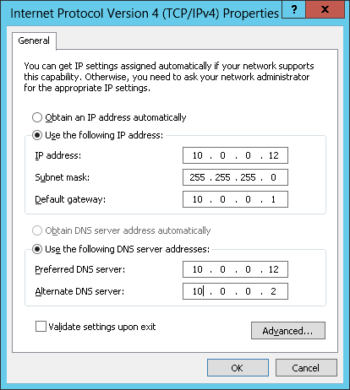

Install Active Directory and DNS Server
- Add ‘AD Domain Services’ and ‘DNS Server’ roles
(Server Manager / Local Server / Manage / Add Roles and Features)
- Configure the AD Domain Services role
  - Set the root domain name to opm.ec2.internal
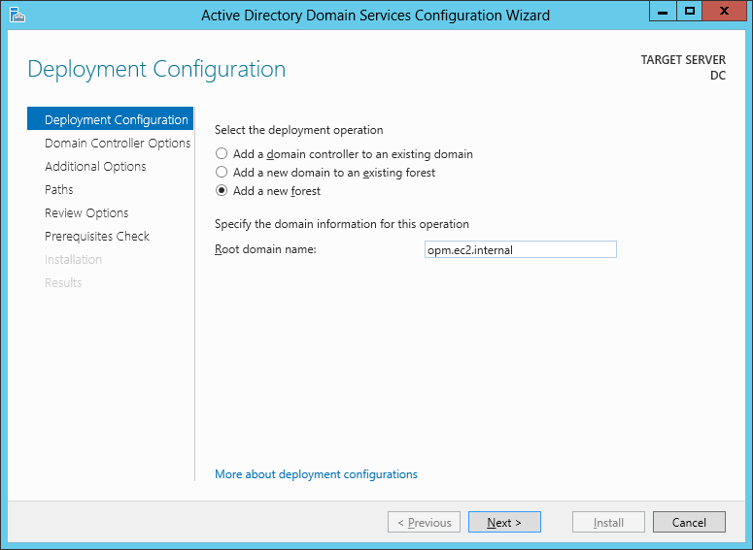

  - Set forest functional level to Windows Server 2003
Set the DSRM password to fy9rcb2Veg5nRyT2
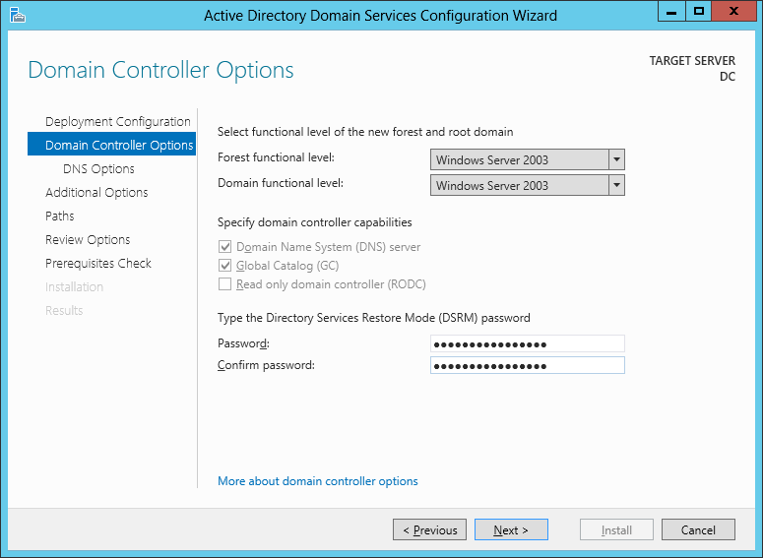

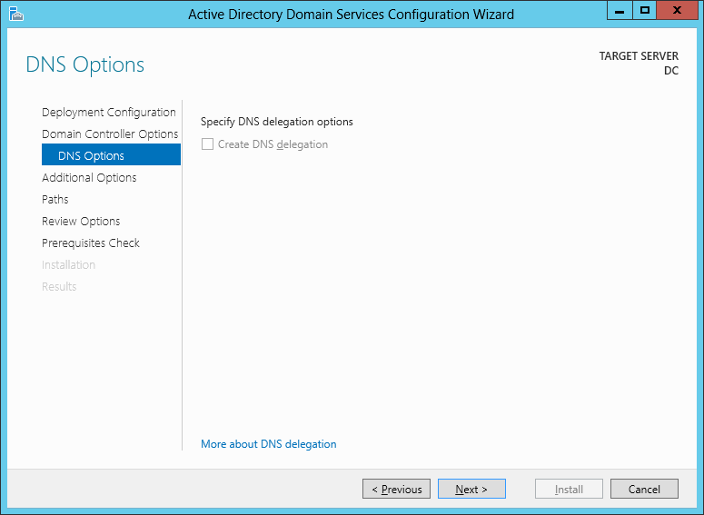
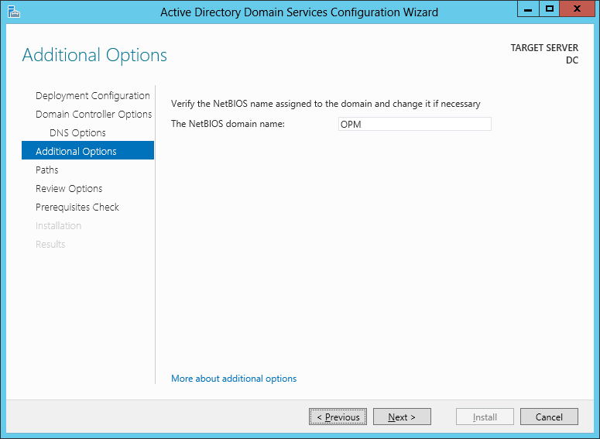

  - The AD files will be stored on a second EBS volume attached to the instance as the drive D.
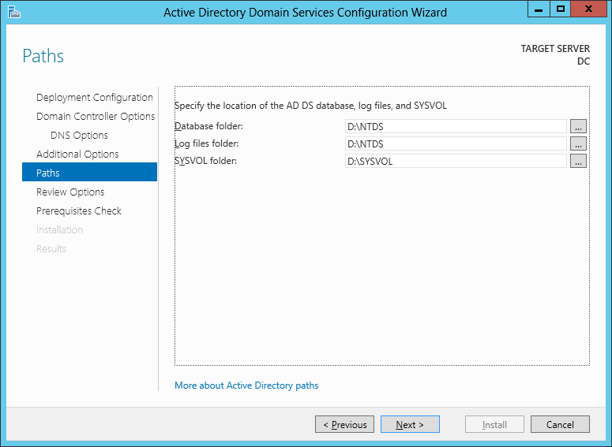

Create AD Groups
Execute PowerShell to create 13 groups
New-ADGroup -Name "Batch Process" -Path "cn=Users,dc=opm,dc=ec2,dc=internal" -groupScope Global
New-ADGroup -Name "Service Credit Reviewer" -Path "cn=Users,dc=opm,dc=ec2,dc=internal" -groupScope Global
New-ADGroup -Name "Receivables Supervisor" -Path "cn=Users,dc=opm,dc=ec2,dc=internal" -groupScope Global
New-ADGroup -Name "Service Credit Specialist" -Path "cn=Users,dc=opm,dc=ec2,dc=internal" -groupScope Global
New-ADGroup -Name "Receivables Technician" -Path "cn=Users,dc=opm,dc=ec2,dc=internal" -groupScope Global
New-ADGroup -Name "Service Credit Data Entry Technician" -Path "cn=Users,dc=opm,dc=ec2,dc=internal" -groupScope Global
New-ADGroup -Name "Financial Technician" -Path "cn=Users,dc=opm,dc=ec2,dc=internal" -groupScope Global
New-ADGroup -Name "Financial Supervisor" -Path "cn=Users,dc=opm,dc=ec2,dc=internal" -groupScope Global
New-ADGroup -Name "Information Technician" -Path "cn=Users,dc=opm,dc=ec2,dc=internal" -groupScope Global
New-ADGroup -Name "System Administrator" -Path "cn=Users,dc=opm,dc=ec2,dc=internal" -groupScope Global
New-ADGroup -Name "FACES User" -Path "cn=Users,dc=opm,dc=ec2,dc=internal" -groupScope Global
New-ADGroup -Name "RIO User" -Path "cn=Users,dc=opm,dc=ec2,dc=internal" -groupScope Global

Create a Domain User for WIS Demo
Start -> Administrative Tools -> Active Directory Users and Computers
Create a new user object:
select New-> User
User name: ScrdAdmin
Password: EBFk9aKKQmnDbYtS
After created right click Properties
move to Member Of tab
add Groups System Administrator, Batch Process and Service Credit Reviewer
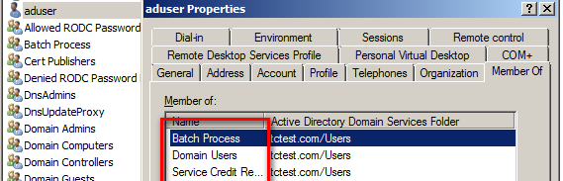

Configure Kerberos Service Principal (keytab)
- Start -> Administrative Tools -> Active Directory Users and Computers
- Create a new user object:
select New-> User
User name: jboss
Password: pZ3FdCAkPvUG9Pb2
only check Password never expires
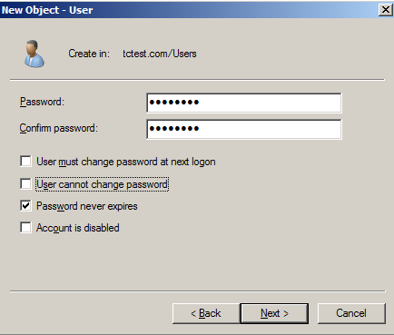
- Open Command Prompt with Run as administrator
Use the setspn utility to create the Service Principal Names (SPNs).
setspn -a HTTP/rhel.opm.ec2.internal@OPM.EC2.INTERNAL jboss
and then
ktpass /princ HTTP/rhel.opm.ec2.internal@OPM.EC2.INTERNAL /pass "pZ3FdCAkPvUG9Pb2" /mapuser jboss /out krb5.keytab /ptype KRB5_NT_PRINCIPAL /kvno 0 /crypto RC4-HMAC-NT
- Copy the krb5.keytab file to the New Application / Database Server VM (more instructions are below)

New Application / Database Server VM
Download the required 3rd party software distribution packages
Folder | Description
~/dist/jdk-6u45-linux-x64.rpm.bin | Java 6  http://www.oracle.com/
~/dist/jboss-eap-6.1.0.zip | JBoss EAP 6.1  http://www.jboss.org/
~/dist/pgdg-redhat92-9.2-7.noarch.rpm | PostgreSQL 9.2.4  http://www.postgresql.org/
~/dist/apache-ant-1.8.1-bin.zip | Ant 1.8.1  http://ant.apache.org/

Java 6
chmod +x ~/dist/jdk-6u45-linux-x64.rpm.bin
sudo ~/dist/jdk-6u45-linux-x64.rpm.bin

vim ~/.bash_profile
# JAVA_HOME=/usr/java/jdk1.6.0_45
# export JAVA_HOME
#
# PATH=$PATH:$HOME/bin:$JAVA_HOME/bin

Verification steps
- Verify that JDK is installed and its version is 1.6
$ /usr/java/jdk1.6.0_45/bin/java –version
java version "1.6.0_45"
Java(TM) SE Runtime Environment (build 1.6.0_45-b06)
Java HotSpot(TM) 64-Bit Server VM (build 20.45-b01, mixed mode)

JBoss EAP 6.1

Install JBoss EAP
# create a Linux user which jboss will run as
sudo adduser jboss

# extract and install the JBoss runtime
sudo unzip ~/dist/jboss-eap-6.1.0.zip -d /usr/share
sudo ln -s -T /usr/share/jboss-eap-6.1 /usr/share/jboss-as
sudo chown -R jboss:jboss /usr/share/jboss-eap-6.1

# create a JBoss management user
sudo -u jboss /usr/share/jboss-as/bin/add-user.sh
# 1. Management User
# 2. ManagementRealm
# 3. User name: jboss
# 4. Password: G#Nsfkm9j8RBykFG
# 5. no

# allow listening on any IP
sudo -u jboss cp /usr/share/jboss-as/standalone/configuration/standalone.xml /usr/share/jboss-as/standalone/configuration/standalone.xml.orig
sudo -u jboss vim /usr/share/jboss-as/standalone/configuration/standalone.xml
# <interface name="management">
# <inet-address value="${jboss.bind.address:0.0.0.0}"/>
# </interface>
#
# <interface name="public">
# <inet-address value="${jboss.bind.address:0.0.0.0}"/>
# </interface>

# specify the JVM to use
sudo -u jboss cp /usr/share/jboss-as/bin/standalone.conf /usr/share/jboss-as/bin/standalone.conf.orig
sudo -u jboss vim /usr/share/jboss-as/bin/standalone.conf
# JAVA_HOME="/usr/java/jdk1.6.0_45"

# create a RHEL service to run JBoss EAP 6.1 Standalone
sudo ln -s -T /usr/share/jboss-eap-6.1/bin/init.d/jboss-as-standalone.sh /etc/init.d/jboss-as

sudo mkdir /etc/jboss-as
sudo ln -s /usr/share/jboss-eap-6.1/bin/init.d/jboss-as.conf /etc/jboss-as/jboss-as.conf
sudo chown -R jboss:jboss /etc/jboss-as

# set run-as user name
sudo -u jboss cp /usr/share/jboss-eap-6.1/bin/init.d/jboss-as.conf /usr/share/jboss-eap-6.1/bin/init.d/jboss-as.conf.orig
sudo -u jboss vim /etc/jboss-as/jboss-as.conf
# JBOSS_USER=jboss

sudo chkconfig --add jboss-as
sudo chkconfig jboss-as on

# start the service
sudo service jboss-as start
# sudo service jboss-as stop
# sudo service jboss-as restart
# the management console is listening on 0.0.0.0:9990
# the web server is listening on 0.0.0.0:8080

# enable the incoming tcp:8080 connections in the RH firewall
sudo yum install system-config-firewall
sudo system-config-firewall

Verification steps
- Check that JBoss default website opens on ${vm-dns-name}:8080
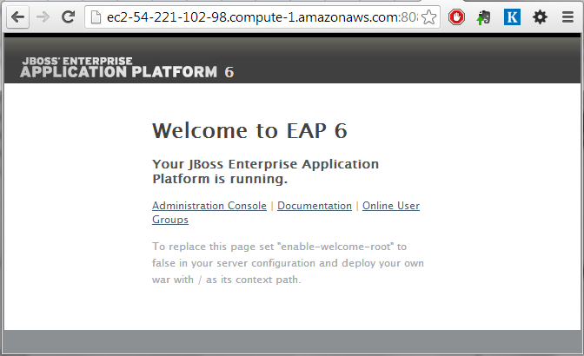
- Check that JBoss Management console opens at localhost:9990 and the username/password match (jboss / G#Nsfkm9j8RBykFG)
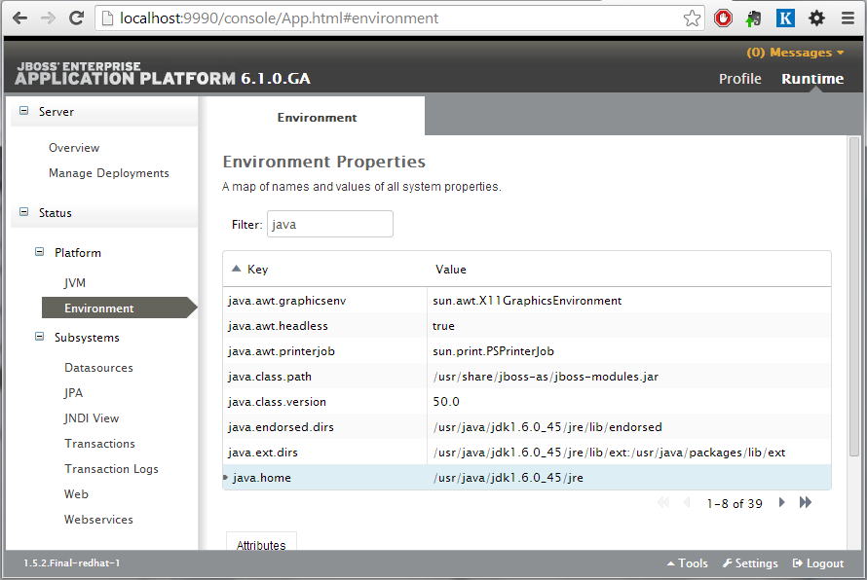
- Check that the JVM version is correct (java.home = /usr/java/jdk1.6.0_45/jre)

Install software components for kerberos
sudo yum install openldapclients nss-pam-ldapd pam_krb5

Configure static IP and host name
sudo vim /etc/sysconfig/network-scripts/ifcfg-eth0

DEVICE=eth0
BOOTPROTO=dhcp
ONBOOT=on
DNS1=10.0.0.12
DNS2=10.0.0.2

Make sure DNS is set to the private IP of the Domain Controller
sudo hostname rhel.opm.ec2.internal
sudo vim /etc/sysconfig/network

NETWORKING=yes
NETWORKING_IPV6=no
HOSTNAME=rhel.opm.ec2.internal

sudo service network restart

Add Domain Controller VM IP to hosts if there is an error when ping opm.ec2.internal
sudo vim /etc/hosts
10.0.0.12 dc.opm.ec2.internal
10.0.0.12 opm.ec2.internal

Verification
ping opm.ec2.internal
should return successful message

Configure Kerberos Client
sudo vim /etc/krb5.conf

[logging]
default = FILE:/var/log/krb5libs.log
kdc = FILE:/var/log/krb5kdc.log
admin_server = FILE:/var/log/kadmind.log

[libdefaults]
default_realm = OPM.EC2.INTERNAL
dns_lookup_realm = false
dns_lookup_kdc = false
ticket_lifetime = 24h
renew_lifetime = 7d
forwardable = true

[realms]
OPM.EC2.INTERNAL = {
kdc = dc.opm.ec2.internal:88
}

[domain_realm]
.OPM.EC2.INTERNAL = OPM.EC2.INTERNAL
OPM.EC2.INTERNAL = OPM.EC2.INTERNAL

Make sure the time in the Domain Controller and JBoss server same. Kerberos may fail when time different more than 5 minutes between client and server. See http://blogs.msdn.com/b/asiatech/archive/2009/04/27/kerberos-authentication-failed-due-to-time-skew.aspx
Verification steps
root$ kinit Administrator@OPM.EC2.INTERNAL
Password for Administrator@OPM.EC2.INTERNAL:

# list the Ticket
root$ klist
Ticket cache: FILE:/tmp/krb5cc_0
Default principal: Administrator@OPM.EC2.INTERNAL

Valid starting Expires Service principal
09/17/13 15:55:42 09/18/13 01:55:52 krbtgt/OPM.EC2.INTERNAL@OPM.EC2.INTERNAL
renew until 09/24/13 15:55:42

Configure JBoss to use Kerberos
- Install the krb5.keytab file into /home/jboss/krb5.keyfile
(make sure it is readable for the jboss user)
- Modify standalone/configuration/standalone.xml
add security domain host and SPNEGO
use the path to the keytab file created in 1.4.5
<security-domain name="host" cache-type="default">
<authentication>
<login-module code="Kerberos" flag="required">
<module-option name="storeKey" value="true"/>
<module-option name="useKeyTab" value="true"/>
<module-option name="principal" value="HTTP/rhel.opm.ec2.internal@OPM.EC2.INTERNAL"/>
<module-option name="keyTab" value="/home/jboss/krb5.keytab"/>
<module-option name="doNotPrompt" value="true"/>
<module-option name="debug" value="true"/>
</login-module>
</authentication>
</security-domain>
<security-domain name="SPNEGO" cache-type="default">
<authentication>
<login-module code="org.jboss.security.negotiation.spnego.SPNEGOLoginModule" flag="requisite">
<module-option name="password-stacking" value="useFirstPass"/>
<module-option name="serverSecurityDomain" value="host"/>
</login-module>
<login-module code="org.jboss.security.negotiation.spnego.AdvancedLdapLoginModule" flag="required">
<module-option name="password-stacking" value="useFirstPass"/>
<module-option name="bindAuthentication" value="GSSAPI"/>
<module-option name="jaasSecurityDomain" value="host"/>
<module-option name="java.naming.provider.url" value="ldap://DC.OPM.EC2.INTERNAL:3268"/>
<module-option name="baseCtxDN" value="CN=Users,DC=opm,DC=ec2,DC=internal"/>
<module-option name="baseFilter" value="(userPrincipalName={0})"/>
<module-option name="roleAttributeID" value="memberOf"/>
<module-option name="roleAttributeIsDN" value="true"/>
<module-option name="roleNameAttributeID" value="cn"/>
<module-option name="recurseRoles" value="true"/>
</login-module>
</authentication>
</security-domain>

Verification steps
sudo kdestroy
sudo kinit -k -t /home/jboss/krb5.keytab HTTP/rhel.opm.ec2.internal@OPM.EC2.INTERNAL
sudo klist

Ticket cache: FILE:/tmp/krb5cc_0
Default principal: HTTP/rhel.opm.ec2.internal@OPM.EC2.INTERNAL

Valid starting Expires Service principal
03/07/14 18:20:27 03/08/14 04:20:25 krbtgt/OPM.EC2.INTERNAL@OPM.EC2.INTERNAL
renew until 03/14/14 19:20:27

PostgresSQL 9.2
sudo yum install ~/dist/pgdg-redhat92-9.2-7.noarch.rpm
sudo yum install postgresql92-server postgresql92-contrib
sudo service postgresql-9.2 initdb
sudo chkconfig postgresql-9.2 on
sudo service postgresql-9.2 start

# create the scrd user and database
sudo -u postgres /usr/pgsql-9.2/bin/psql
# CREATE USER scrd WITH PASSWORD 'MMJUEKAvCJyLvuGj';
# CREATE DATABASE scrd;
# GRANT ALL PRIVILEGES ON DATABASE scrd to scrd;

# add psql to the PATH
export PATH=$PATH:/usr/pgsql-9.2/bin

# allow the scrd user connection to PostgresSQL from the localhost
sudo vim /var/lib/pgsql/9.2/data/pg_hba.conf
# TYPE DATABASE USER ADDRESS METHOD
# host scrd scrd 127.0.0.1/32 md5
# local scrd scrd md5
sudo service postgresql-9.2 reload

Verification steps
- Verify that psql command line tool is installed and the PostgresSQL version is 9.2:
$ /usr/pgsql-9.2/bin/psql –V
psql (PostgreSQL) 9.2.6

- Verify that scrd user can connect to PostgresSQL with the password MMJUEKAvCJyLvuGj:
$ /usr/pgsql-9.2/bin/psql -U scrd -W scrd
Password for user scrd:
psql (9.2.6)
Type "help" for help.

scrd=>

Apache Ant 1.8.1
sudo unzip ~/dist/apache-ant-1.8.1-bin.zip -d /usr/share
vim ~/.bash_profile
# ANT_HOME=/usr/share/apache-ant-1.8.1
# export ANT_HOME
#
# PATH=$PATH:$HOME/bin:$ANT_HOME/bin

Verification steps
- Verify that ant command line tool is installed and the Ant version is 1.8.1:
$ ant -version
Apache Ant version 1.8.1 compiled on April 30 2010

Legacy Database Server / Domain Member VM

Configure the Microsoft SQL Server
- Launch the SQL Server Management Studio (run ssms.exe)
- Connect to localhost with the Windows Authentication
- Right click on the localhost SQL Server instance in the Object Explorer
- Select Properteis / Security
- Enable the “SQL Server and Windows Authentication Mode” option
- Click OK
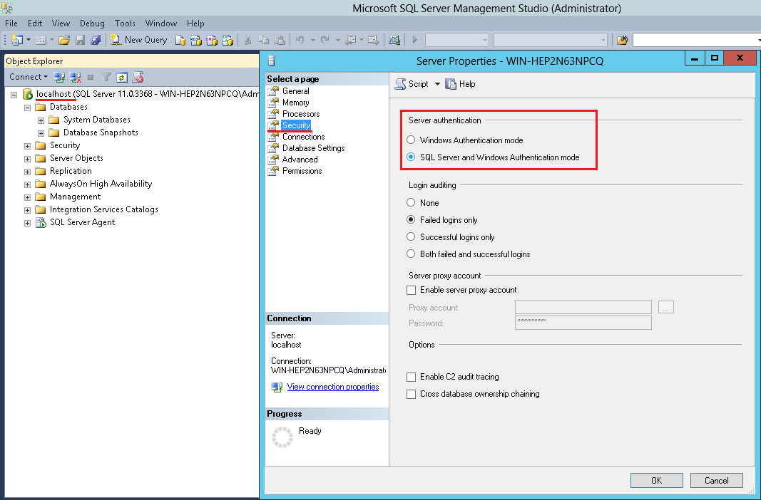

Create the ServiceCredit database
(continue with the SQL Server Management Studio)
- Right click on the Databases in the Object Explorer
- Select “New Database…”
- Give the new database the name ‘ServiceCredit’
- Specify the initial database size (100MB, growing by 100MB) and the initial log size (10MB, growing by 10%)
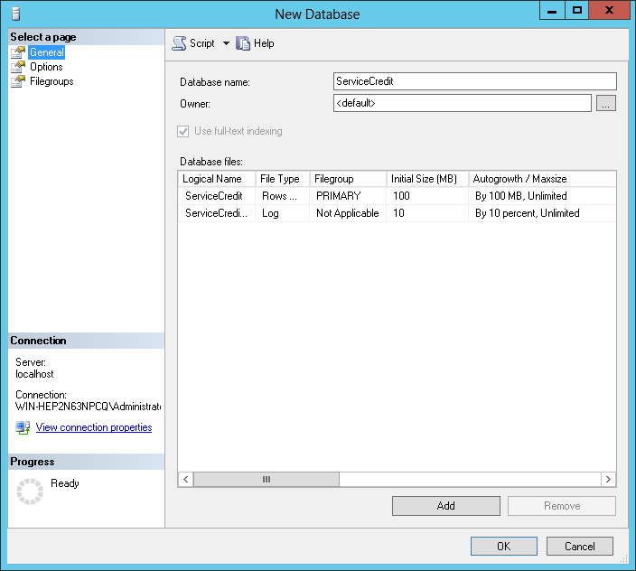
- Set the compatibility level to “SQL Server 2005”
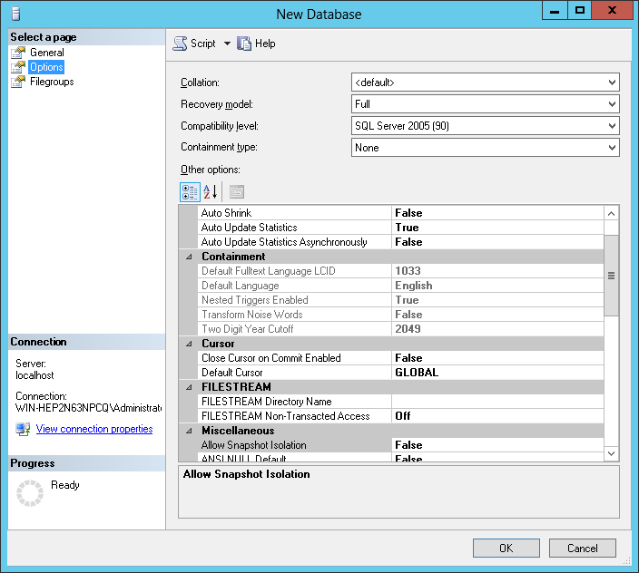
- Click OK to create the database

Create the scrd_migration user with the permissions to read the ServiceCredit database
(continue with the SQL Server Management Studio)
- Right click on the Security / Logins in the Object Browser and select the ‘sdf’ option
- Enter the user name ‘scrd_migration’, select the ‘SQL Server Authentication’ option, enter the password (mtL5JUc7kuUCCpjx), unselect the ‘Enforce password expiration’ checkbox and select the default database for the user to be ‘ServiceCredit’:
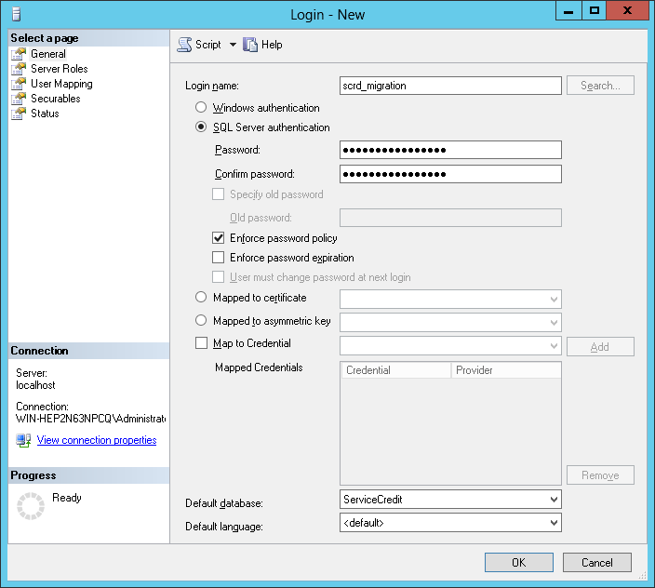
- Switch to the ‘User Mapping’ tab and assign read and write permissions on the ServiceCredit database:
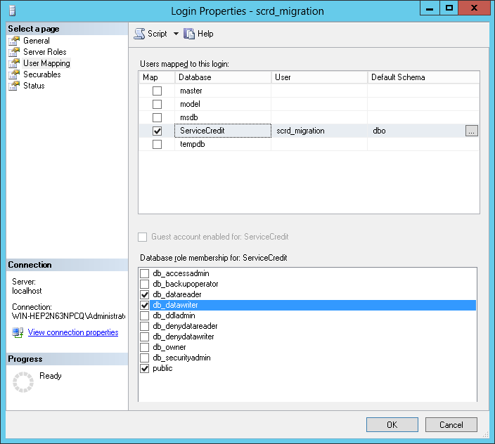
- Click OK to create the user

Configure DNS
DNS server: 10.0.0.12 (private IP of the Domain Controller)

Join the AD domain
- Set the computer name to WORKSTATION
- Join the opm.ec2.intrnal domain. Use the Domain Controller VM’s Administrator account when prompted.
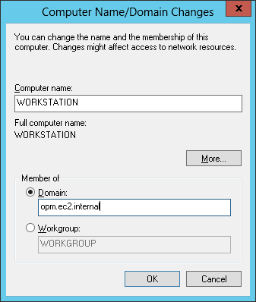

- restart the VM
- add the ‘OPM/Domain Users’ group into the ‘Remote Desktop Users’
- Add the OPM/ScrdAdmin used into the Administrators group

Configure domain name for JBoss server
- After restart and login as OPM/ScrdAdmin
- Check that the DNS name rhel.opm.ec2.internal resolves
ping rhel.opm.ec2.internal

Configure IE
Tools->Internet Options
move to Security tab
click Local intranet and click Sites and click Advanced
add site http://rhel.opm.ec2.internal
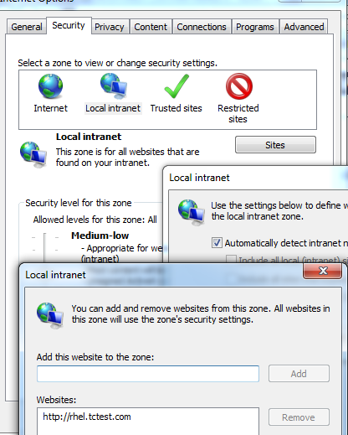

Configure Firefox
input url about:config
modify value
network.negotiate-auth.trusted-uris=http://rhel.opm.ec2.internal
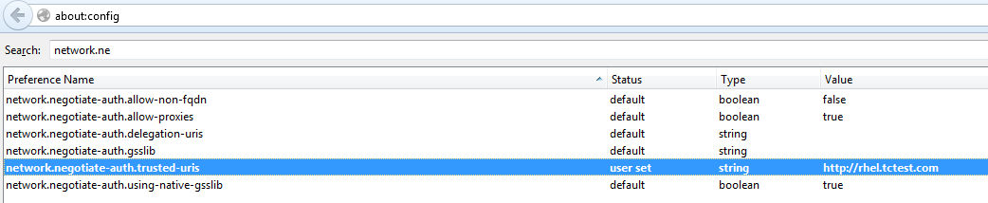

Configure Chrome
It will use configuration by IE. So please configure IE actually

Deployment Instructions
Check-out the code for deployment from SVN (use your user name and type password when prompted)
mkdir ~/deploy
svn checkout https://coder.topcoder.com/tcs/clients/coeci-opm/Delivery/Code/ ~/deploy/svn-code --username [username]

Folder | Description
~/deploy/svn-code/Batch_Processing | Batch Processing module
~/deploy/svn-code/Data_Migration | Data Migration module
~/deploy/svn-code/FACES | FACES web application
~/deploy/svn-code/SCRD_BRE | SCRD web application + BRE
~/deploy/svn-code/Windows_Security_Integration | WIS demo module

SCRD_BRE module
Create a local build.properties file:
cd ~/deploy/svn-code/SCRD_BRE
cp build.properties.template build.properties
vim build.properties

# The installation location of JBoss EAP 6.1
jboss.home=/usr/share/jboss-eap-6.1

# The log path and name used for knowledge execution
log_dir=/var/log/scrd

# The directory that contains the rules files.
opm.drools.rules.directory=/usr/share/scrd-rules

# JDBC details
db.driver=org.postgresql.Driver
db.url=jdbc:postgresql://localhost:5432/scrd
db.user=scrd
db.pass=MMJUEKAvCJyLvuGj

Create the logs directory writable for the jboss user
sudo mkdir -m 755 /var/log/scrd
sudo chown jboss:jboss /var/log/scrd

Deploy the business rules
sudo mkdir -m 755 /usr/share/scrd-rules
sudo cp conf/rules/* /usr/share/scrd-rules/

sudo chown -R jboss:jboss /usr/share/scrd-rules
sudo chmod 644 /usr/share/scrd-rules/*

Install the PostgresSQL DB Connector for JBoss
sudo -u jboss cp -r conf/jboss/modules/org /usr/share/jboss-as/modules/system/layers/base/

sudo -u jboss vim /usr/share/jboss-as/standalone/configuration/standalone.xml

<driver name="postgresql-jdbc4" module="org.postgresql">
<driver-class>org.postgresql.Driver</driver-class>
</driver>

Prepare the database
ant db-create

Run unit tests
# set the permissions necessary for to run the unit tests as ec2-user
sudo chown -R ec2-user:ec2-user /var/log/scrd
sudo chown -R ec2-user:ec2-user /usr/share/scrd-rules

ant test

# restore the permissions for the jboss user
sudo chown -R jboss:jboss /var/log/scrd
sudo chown -R jboss:jboss /usr/share/scrd-rules

Deploy the application
ant dist-ear
ant db-test-data
sudo -u jboss cp dist/opm.ear /usr/share/jboss-eap-6.1/standalone/deployments/opm.ear
sudo -u jboss touch /usr/share/jboss-eap-6.1/standalone/deployments/opm.ear.dodeploy

Verification steps are described in the SCRD_BRE deployment guide documents under SCRD_BRE/doc.

FACES module
Create a local build.properties file:
cd ~/deploy/svn-code/FACES
cp build.properties.template build.properties
vim build.properties

# The installation location of JBoss EAP 6.1
jboss.home=/usr/share/jboss-eap-6.1

# The log path and name used for knowledge execution
log_dir=/var/log/scrd

# JDBC details
db.driver=org.postgresql.Driver
db.url=jdbc:postgresql://localhost:5432/scrd
db.user=scrd
db.pass=MMJUEKAvCJyLvuGj

Run unit tests
(use the database schema created during the SCRD_BRE deployment)
# set the permissions necessary for to run the unit tests as ec2-user
sudo chown -R ec2-user:ec2-user /var/log/scrd
sudo chown -R ec2-user:ec2-user /usr/share/scrd-rules

ant test

# restore the permissions for the jboss user
sudo chown -R jboss:jboss /var/log/scrd
sudo chown -R jboss:jboss /usr/share/scrd-rules

Deploy the application
ant dist-ear
sudo -u jboss cp dist/faces.ear /usr/share/jboss-eap-6.1/standalone/deployments/
sudo -u jboss touch /usr/share/jboss-eap-6.1/standalone/deployments/faces.ear.dodeploy

Restore the SCRD_BRE test data
cd ../SCRD_BRE
ant db-test-data

Verification steps are described in the FACES deployment guide documents under FACES/doc.

Batch_Processing

Create a local build.properties file:
cd ~/deploy/svn-code/Batch_Processing
cp build.properties.template build.properties
vim build.properties

# The log path and name used for knowledge execution
log_dir=/var/log/scrd

# JDBC details
db.driver=org.postgresql.Driver
db.url=jdbc:postgresql://localhost:5432/scrd
db.user=scrd
db.pass=MMJUEKAvCJyLvuGj

Run unit tests
(use the database schema created during the SCRD_BRE deployment)
# set the permissions necessary for to run the unit tests as ec2-user
sudo chown -R ec2-user:ec2-user /var/log/scrd
sudo chown -R ec2-user:ec2-user /usr/share/scrd-rules

ant test

# restore the permissions for the jboss user
sudo chown -R jboss:jboss /var/log/scrd
sudo chown -R jboss:jboss /usr/share/scrd-rules

Restore the SCRD_BRE test data
cd ../SCRD_BRE
ant db-test-data

Verification steps are described in the Batch_Processing deployment guide documents under Batch_Processing/doc.

Data_Migration
Prepare the source data (Microsoft SQL Server VM)
Execute
- Data_Migration/src/sql/create-ServiceCredit.sql
- Data_Migration/src/sql/source-data.sql
against the ServiceCredit database on the Microsoft SQL Server.

Create a local build.properties file:
cd ~/deploy/svn-code/Data_Migration
cp build.properties.template build.properties
vim build.properties

# The installation location of JBoss EAP 6.1
jboss.home=/usr/share/jboss-eap-6.1

# The log path and name used for knowledge execution
log_dir=/var/log/scrd

# JDBC details
db.driver=org.postgresql.Driver
db.url=jdbc:postgresql://localhost:5432/scrd
db.user=scrd
db.pass=MMJUEKAvCJyLvuGj

# Migration Source Database details
db.sourceDatabaseDriverName=com.microsoft.sqlserver.jdbc.SQLServerDriver
db.sourceDatabaseUrl=jdbc:sqlserver://10.0.0.188:1433;databaseName=ServiceCredit;
db.sourceDatabaseUsername=scrd_migration
db.sourceDatabasePassword=mtL5JUc7kuUCCpjx

Run unit tests
(use the database schema created during the SCRD_BRE deployment)
# set the permissions necessary for to run the unit tests as ec2-user
sudo chown -R ec2-user:ec2-user /var/log/scrd
sudo chown -R ec2-user:ec2-user /usr/share/scrd-rules

ant test

# restore the permissions for the jboss user
sudo chown -R jboss:jboss /var/log/scrd
sudo chown -R jboss:jboss /usr/share/scrd-rules

Restore the SCRD_BRE test data
cd ../SCRD_BRE
ant db-test-data

Make distributable .jar file (Data_Migration/dist/processor.jar)
cd ../Data_Migration
ant dist-migration

Verification steps are described in the Data_Migration deployment guide documents under Data_Migration/doc.

Windows_Security_Integration
Create a local build.properties file:
cd ~/deploy/svn-code/Data_Migration
cp build.properties.template build.properties
vim build.properties

# The installation location of JBoss EAP 6.1
jboss.home=/usr/share/jboss-eap-6.1
war.dist.name=wispoc.war

# JDBC details
db.driver=org.postgresql.Driver
db.url=jdbc:postgresql://localhost:5432/scrd
db.user=scrd
db.pass=MMJUEKAvCJyLvuGj

Build the application
ant war

Deploy it
sudo -u jboss cp build/dist/wispoc.war /usr/share/jboss-eap-6.1/standalone/deployments/wispoc.war
sudo -u jboss touch /usr/share/jboss-eap-6.1/standalone/deployments/wispoc.war.dodeploy

Verification steps are described in the Windows_Security_Integration deployment guide documents under Windows_Security_Integration/doc.

Starting

SCRD_BRE module
Start JBoss if it not running (sudo service jboss-as restart). The frontend application is automatically started when the JBoss server is started.

Application is then available on http://54.84.187.152:8080/scrd from the Internet and on http://rhel.opm.ec2.internal:8080/scrd from the Domain Member (user1 / 123456).

FACES module
Start JBoss if it not running (sudo service jboss-as restart). The frontend application is automatically started when the JBoss server is started.

Application is then available on http://54.84.187.152:8080/faces from the Internet and on http://rhel.opm.ec2.internal:8080/faces from the Domain Member (user5 / 123456).

Batch_Processing
cd ~/deploy/svn-code/Batch_Processing
ant run-batch

Data_Migration
Run the migration
cd ~/deploy/Data_Migration
java -jar dist/processor.jar

Windows_Security_Integration
Start JBoss if it not running (sudo service jboss-as restart). The frontend application is automatically started when the JBoss server is started.

Application is then available on http://54.84.187.152:8080/wispoc from the Internet and on http://rhel.opm.ec2.internal:8080/wispoc from the Domain Member.

Verification
The verification steps are described in the corresponding deployment documents for each module.

Resource Contact List
Name | Resource Email
lukashov

